**ACCESS TO HSU PROFESSORS AND STUDENTS’ BASIC INFORMATION OF UNIVERSITY OF MAKATI**

**S.Y 2019 – 2020**

**A Research Paper Presented to the**

**Higher School Ng UMak,**

**University of Makati**

**In partial fulfillment**

**of the requirements for Research Project**

**Technical-Vocational-Livelihood (TVL)**

**TADEA, NEIL GABRIEL E.**

**OR, CHONY M.**

**LACONSAY, MHIKE LAURENCE**

**SANQUI, CHASTINE JOY**

**VIRYOSO, KELLY MARISTHEL U.**

**JANUARY 2020**

**INTRODUCTION**

Professors are the ones responsible for guiding the students throughout their time in school. Most of the time, they have a hard time looking for their class and do forget to give some of their basic information. Sometimes the students would like to know more about their Professors basic information such as their names, department. The researcher’s program will be dealing with Professor’s basic information.

Programming is essential in these days because most industry has an IT department in it. Programming makes things more convenient to people and make life easier. The importance of programs is known by means of necessity to the industry.

This program will be a big advantage to both student and Professor as it will be more convenient to access to their basic information. Giving some basic information may help to fill the curiousness of their students and may recognize them as easy as they click the program. It is a two-way program, Professors can see the student information such as name, age, section and students can see the Professor’s basic information by just searching in the search bar in the program.

This study focused on the access to Higher School ng UMak Professors and student’s basic information of University of Makati S.Y. 2019 – 2020. In the study, the researchers limit the population of randomly selected Higher School ng UMak professors and students of University of Makati due to lack of time.

The program will ask the user for user login and password, the program will automatically know if the user is a professor or a student base on the user login. If the user is a professor then it will show the selection for the HSU sections and if the user is a student the program will show a search bar for the name of the professors that the student wants to search.

**METHODOLOGY**

Under this Methodology, explains how the students and professors interact with the program the researcher’s have made. It displays the:

**Policy**

* Admin has the authority to display and edit the basic information of the professors as well as the basic information of the students of HSU and their schedule.
* Students should be part of the HSU Department of University of Makati.
* Student should use their ID number as username and the password that will be provided by the admin.
* Professors should be part of the HSU Department of University of Makati.
* Professors are to use the username and the password that will be provided by the admin.

**DIRECTIONS**

**For Administrators:**

* To use the program, enter Admin username and password then click the login button.
* Once logged in, five buttons will appear, click the preferred button.
* The first button will show the search option of information of professors.
* The second button will show the search option of information of the students.
* The third button will allow the admin to edit or fill up the information of professors.
* The fourth button will allow the admin to edit or fill up the information of students.
* The fifth button will allow the admin to exit the program

**Login Form**

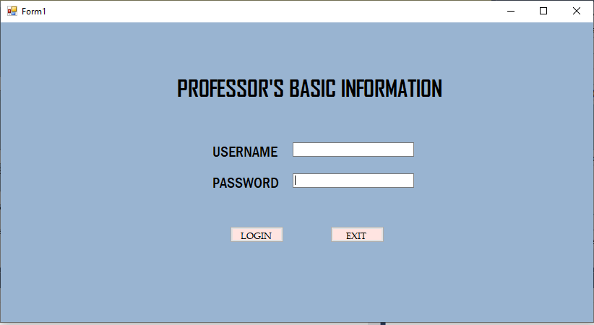

**Administrator Interface**

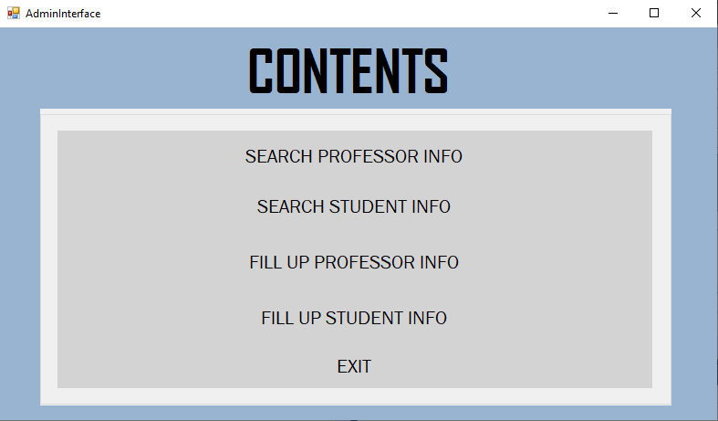

**For students:**

* To use the program, the students must enter their ID number and password given by the Admin and click the login button.
* Once logged in, the students will be able to see the search button in the lower left corner.
* Before searching, the student can select between the first name, middle name, and last name to be searched.
* Enter the name of the professor that is desired to be searched then click the search button.
* Once clicked, it will display the basic information of the searched professor.
* Once done, click exit to close the program.

Login Form



Professors’s Search Form

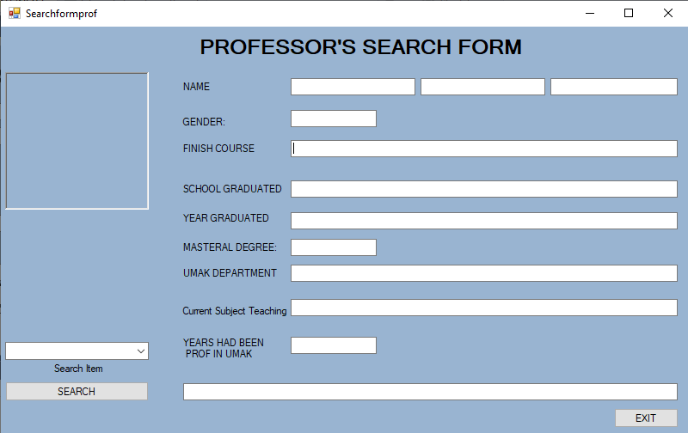

**For Professors:**

* To use the program, Professors must enter the username and password given to them by the admin and click the login button.
* Once logged in, the professors will be able to see a search button in the upper right corner.
* Before searching, the professor can select between the first name, middle name, last name and ID number.
* Enter the name or ID number of the student that is desired to be searched, then click the search button.
* Once clicked, it will display the name, section, ID number and schedule of the Student.
* Once done, click exit to close the program.

Login Form



Student’s Search Form

